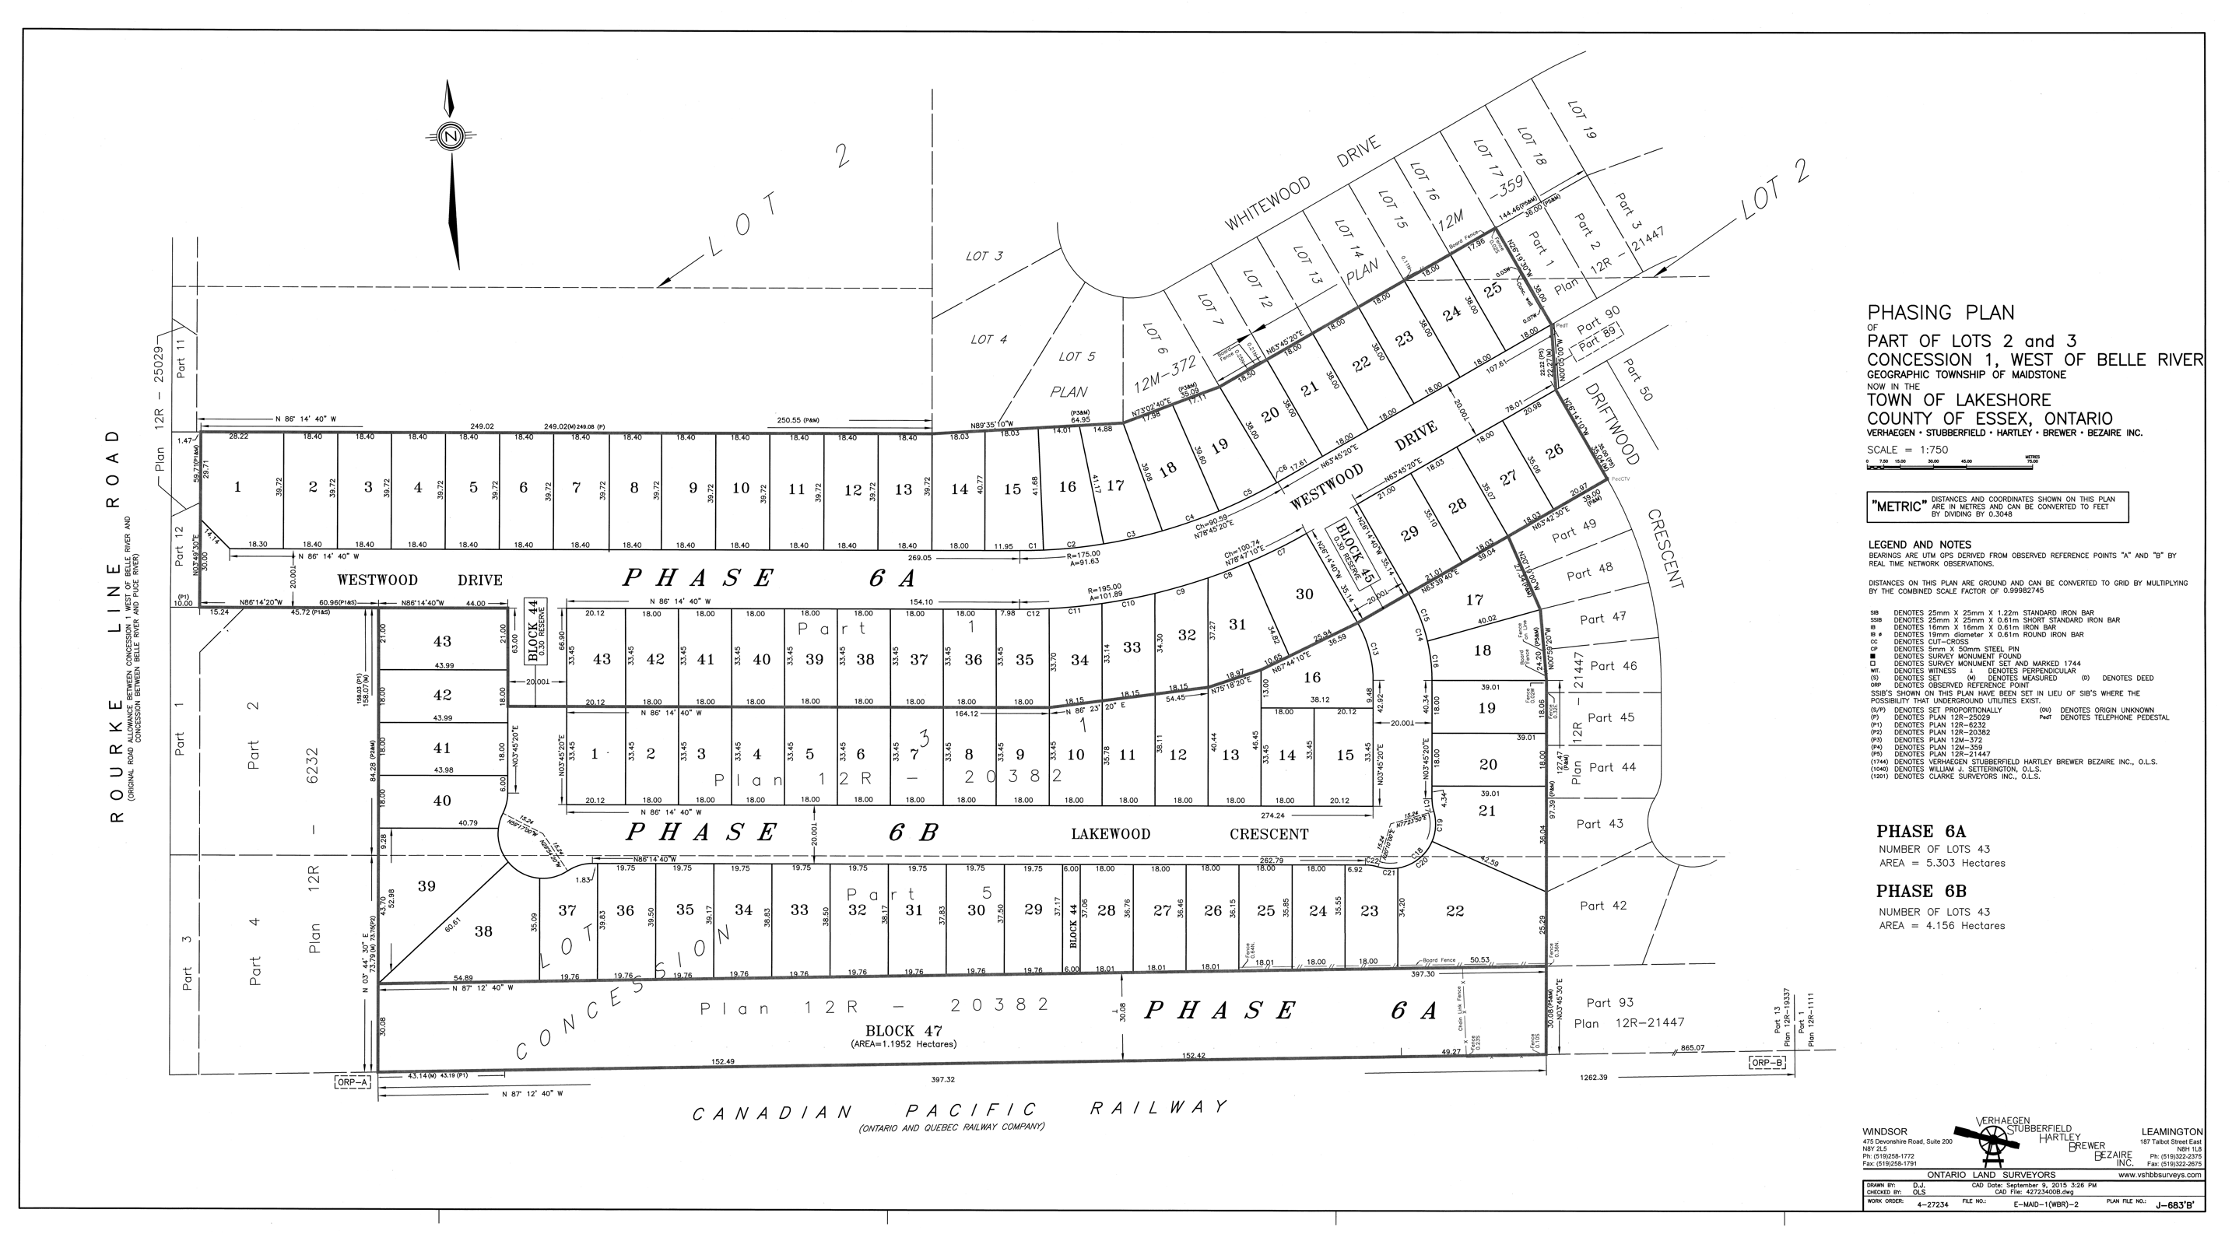



WHITEWOOD ESTATES

AVAILABLE LOTS IN BLUE

WE CURRENTLY HAVE 3 REMAINING LOTS AVAILABLE

CONTACT US IF YOUR INTERESTED IN MORE INFORMATION

WHITEWOOD ESTATES IS LOCATED IN LAKESHORE OFF ROURKE LINE

SOLD OUT!